
SOFTWARE REQUIREMENTS SPECIFICATION
PakTour Planner
A Graph-Based Route Optimisation Engine for Pakistani Tourist Destinations
Course: CS221 – DSA (Data Structures and Algorithms) | Summer 2026
Instructor: Dr. Qamar Abbas

Members:
Shahan Ali – 2024572
Abdullah Saleem – 202439
GitHub Repository:
https://github.com/shahan-giki/PakTour.git

Software Requirements Specification (SRS): PakTour Planner

1 Introduction

1.1 Project Overview
The PakTour Planner is a high-performance, C++17-based tourist route planning engine engineered specifically for the complex geographic landscape of Pakistan. As a sophisticated Data Structures and Algorithms (DSA) implementation, the system utilizes graph-based pathfinding to navigate a network of national destinations. The selection of C++17 provides the architectural foundation necessary for modern memory management (e.g., std::optional for safe path returns) and high-efficiency string parsing (e.g., std::string_view) required to process extensive destination datasets with sub-second latency.

1.2 Purpose of the System
The primary objective of the system is to solve the “shortest-path” problem within a real-world geographic context. It provides users with optimal travel trajectories between Pakistani cities based on dual-metric optimization: travel time, financial cost, or a balanced heuristic of both.

1.3 Scope of the System
The system is bounded by the following functional and technical parameters:
- Graph-Based Optimization: Calculation of routes between Pakistani destinations modeled as nodes and edges.
- Dual-Metric Engine: Support for “Fastest Path” and “Cheapest Path” calculations.
- Seasonal Filtering: Dynamic graph pruning based on accessibility constraints (SUMMER, WINTER, or BOTH/All-Season).
- Algorithmic Rigor: Implementation of Dijkstra's algorithm leveraging a weighted adjacency-list and a binary min-heap priority queue.
- Itinerary Generation: Production of custom travel plans, including “Smart Detour” recommendations for points of interest adjacent to the primary calculated path.

1.4 Assumptions and Constraints
ID | Assumption / Constraint | Description
A1 | C++17 Compliance | The engine assumes an environment with a C++17 standard-compliant compiler (GCC 7+, Clang 5+, or MSVC 2017+) for performance and safety features.
A2 | Pre-formatted Data | Destination and route data are assumed to be provided in structured static files (e.g., CSV) with consistent header schemas.
C1 | Geographic Limitation | The system is strictly limited to the geography and road networks of Pakistan.
C2 | Static Data Loading | The engine utilizes static data loading at initialization; real-time GPS or live traffic telemetry is currently out of scope.
C3 | Non-Negative Weights | All input weights (Time/Cost) must be non-negative to ensure Dijkstra's algorithm convergence.
Table 1: Assumptions and constraints defining the boundaries of the PakTour Planner engine.

2 Stakeholder Analysis

2.1 Stakeholder Classification
Stakeholder | Role | Interest | Influence
Tourists (Users) | Primary Stakeholder | Obtaining fast, cost-effective, and seasonally viable travel routes. | High
Tour Operators | Primary Stakeholder | Building complex itineraries and identifying detours for commercial logistics. | High
System Maintainers | Secondary Stakeholder | Maintaining algorithmic efficiency, code portability, and data integrity. | Medium
Data Providers | Secondary Stakeholder | Ensuring the accuracy of geographic weights and seasonal constraints. | Low
Table 1: Stakeholder classification based on their roles, interest, and influence.

2.2 Elicitation Summary
Requirements were derived through a technical audit of the PakTour repository's implementation of Dijkstra's algorithm and some observations that are made by fellows that Pakistan lacks such organized system. Help from some tourist was also taken. This hybrid approach ensures that the project meets both high-level software engineering standards and specific DSA performance targets.

3 Functional Requirements

3.1 System Feature Matrix
# | Requirement ID | Description | Priority | Stakeholder
1 | FR-101 | The system shall parse external data files into a weighted adjacency-list representing the Pakistani destination graph. | High | System Maintainers
2 | FR-102 | The system shall execute Dijkstra's algorithm to determine the optimal path based on the “Time” metric. | High | Tourists
3 | FR-103 | The system shall execute Dijkstra's algorithm to determine the optimal path based on the “Cost” metric. | High | Tourists / Operators
4 | FR-104 | The system shall implement seasonal filtering to prune nodes designated as 'SUMMER', 'WINTER', or 'BOTH' based on user input. | High | Tourists
5 | FR-105 | The system shall generate itineraries featuring “Smart Detours” by identifying high-weight adjacent nodes to the primary path post-reconstruction. | Medium | Tour Operators
6 | FR-106 | The engine shall utilize a binary min-heap priority queue to manage path exploration and node relaxation. | High | Developers
Table 2: Functional requirement matrix outlining the core features, priorities, and relevant stakeholders.

4 Non Functional Requirements

4.1 Quality Attributes
Requirement ID | Description | Priority | Stakeholder
NFR-201 | Performance: Pathfinding calculations must maintain a time complexity of O(E log V) to ensure sub-second execution on standard hardware. | High | Tourists
NFR-202 | Efficiency: Memory usage shall be optimized via an adjacency list to minimize overhead in sparse geographic graphs compared to an adjacency matrix. | High | Maintainers
NFR-203 | Reliability: The engine must identify and handle unreachable destinations (disconnected graph components) without system failure. | High | All
NFR-204 | Portability: The codebase must remain agnostic of the operating system, provided a standard C++17 compiler is used. | Medium | Maintainers
Table 3: Non-functional requirements defining the system's performance, efficiency, and reliability standards.

5 Requirements Modelling

5.1 Use Case Descriptions
UC-1: Generate Route
- Actor: User (Tourist/Operator).
- Pre-condition: Destination data loaded into memory.
- Main Flow: User provides a start city, end city, and optimization metric. The system performs node relaxation using the min-heap and returns the lowest cumulative weight path.
- Post-condition: The optimal route and total metrics (Time/Cost) are displayed.
UC-2: Apply Seasonal Filter
- Actor: User.
- Pre-condition: Graph initialization complete.
- Main Flow: User selects the current season (Summer, Winter, or All-Season). The system prunes nodes categorized as inaccessible (e.g., removing 'WINTER' nodes during 'SUMMER' queries, while keeping 'BOTH').
- Post-condition: Calculations are restricted to the filtered subgraph.
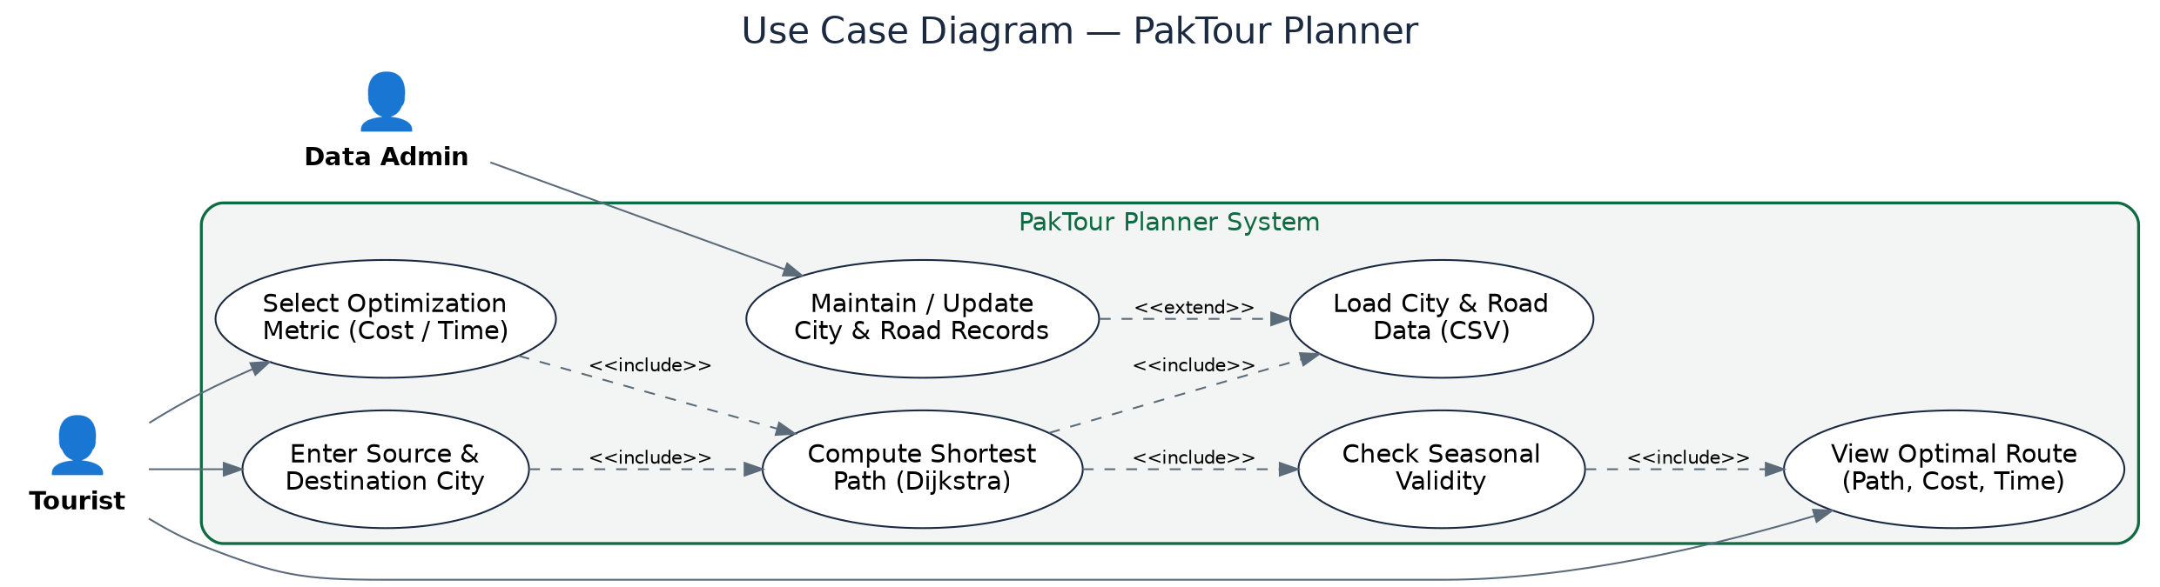
Figure 1: Seasonal filtering use-case flow for the PakTour Planner engine.

5.2 Sequence Logic Description
The architectural flow of a pathfinding request is as follows:
- User Input: Capture of origin, destination, and metric (Cost/Time).
- Graph Filtering: Dynamic pruning of nodes based on seasonal metadata (Summer/Winter/Both).
- Dijkstra Execution: Path exploration via binary min-heap for O(E log V) efficiency.
- Path Reconstruction: Backtracking through predecessor pointers to build the primary route.
- Smart Detour Generation: Post-processing identifying high-weight nodes directly adjacent to the reconstructed path to provide peripheral recommendations.
- Output Display: Presentation of the final itinerary and reconstructed path metrics.
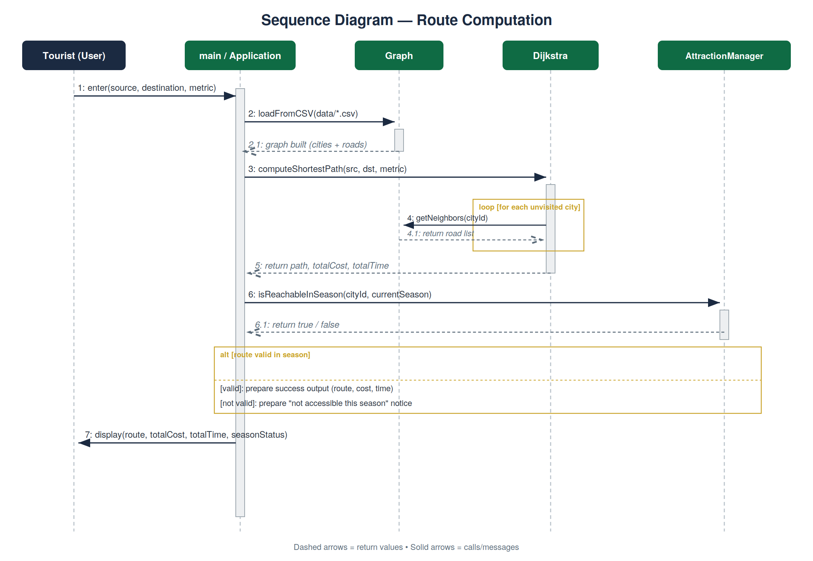
Figure 2: Sequence logic of a pathfinding request, from user input to itinerary output.

5.3 Data Modelling (ER Theory)
The engine models the geographic domain through three core entities:
- Nodes (Destinations): Vertices representing Pakistani cities/sites, including seasonal metadata.
- Edges (Routes): Connections between nodes.
- Weights: Numerical values for Cost and Time. Units (PKR for Cost, Hours for Time) are derived dynamically from static data file headers to ensure logic remains unit-agnostic and configurable. The Adjacency List implementation maps each node to a vector of edge objects, ensuring O(V + E) space complexity, essential for the sparse nature of geographic road networks.
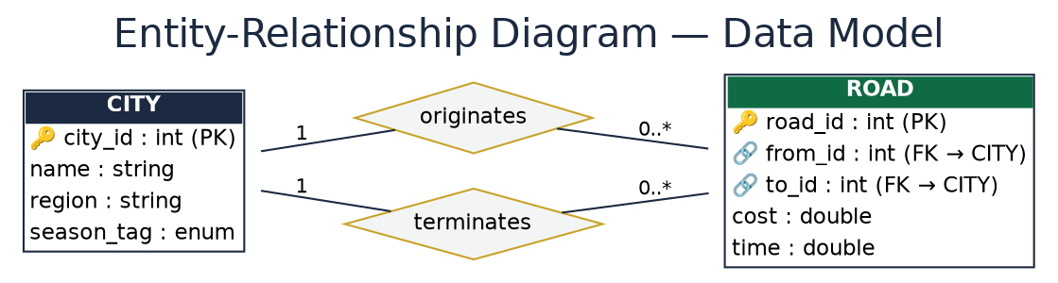
Figure 3: Core entity relationships — Nodes, Edges, and Weights — within the routing graph.

5.4 Class Interaction Modelling
The Class Diagram illustrates the object-oriented structure of the PakTour Planner, highlighting the modular separation between data storage, logical processing, and the application driver.
- main / Application: Acts as the entry point of the system. It coordinates the execution flow by interacting with the Graph for data loading, the AttractionManager for seasonal filtering, and the Dijkstra engine for route computation.
- Graph Class: Serves as the central data repository. It manages an adjacency list composed of City (vertices) and Road (edges) objects. It is responsible for parsing external CSV data and providing neighbor information to the pathfinding engine.
- Dijkstra Class: The core optimization engine. It operates on the Graph to compute the shortest path between a source and destination. It supports dual-metric optimization, allowing it to calculate results based on either total cost or total time.
- AttractionManager: Manages metadata and external constraints. It uses the SeasonTag enum to filter cities based on their accessibility during specific times of the year (Summer, Winter, or Both).
- Road & City Entities: Represent the fundamental units of the transport network. A Road object contains weight data (cost and time) and connects two City objects, while each City carries location data and a specific seasonal availability tag.
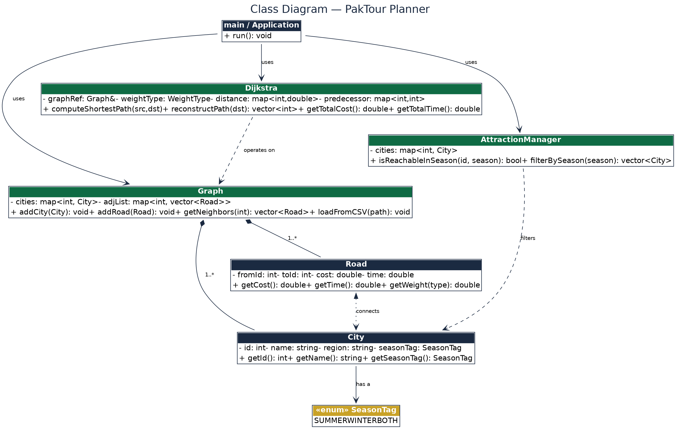
Figure 4: Class interaction diagram showing Graph, Dijkstra, AttractionManager, Road, and City.

5.5 Activity Diagram Note: Route Computation Flow
The Activity Diagram (Figure 5) defines the sequential logic executed when a traveler requests a route. It ensures data integrity and constraint validation before presenting the final itinerary.
- Initialization & Validation: The process begins by loading data from the CSV files. Upon user input of the source and destination, the system performs a City Validity Check. If the inputs do not match the database, an error is displayed immediately.
- Metric Selection: Once validated, the system branches based on the user's priority — Cost or Time. This choice determines which weight the Dijkstra algorithm will prioritize during the search.
- Core Execution: The system runs Dijkstra's Algorithm utilizing a Min-Heap Priority Queue for maximum efficiency. This stage identifies the mathematically shortest path based on the selected metric.
- Constraint Verification: After a path is found, a secondary Seasonal Accessibility Validation is performed. This ensures the suggested route is not only the shortest but also legally and physically reachable in the current travel season.
- Output Generation: The final activity is the detailed display of the Route, Total Cost, and Total Travel Time, providing the user with a complete, optimized travel plan.
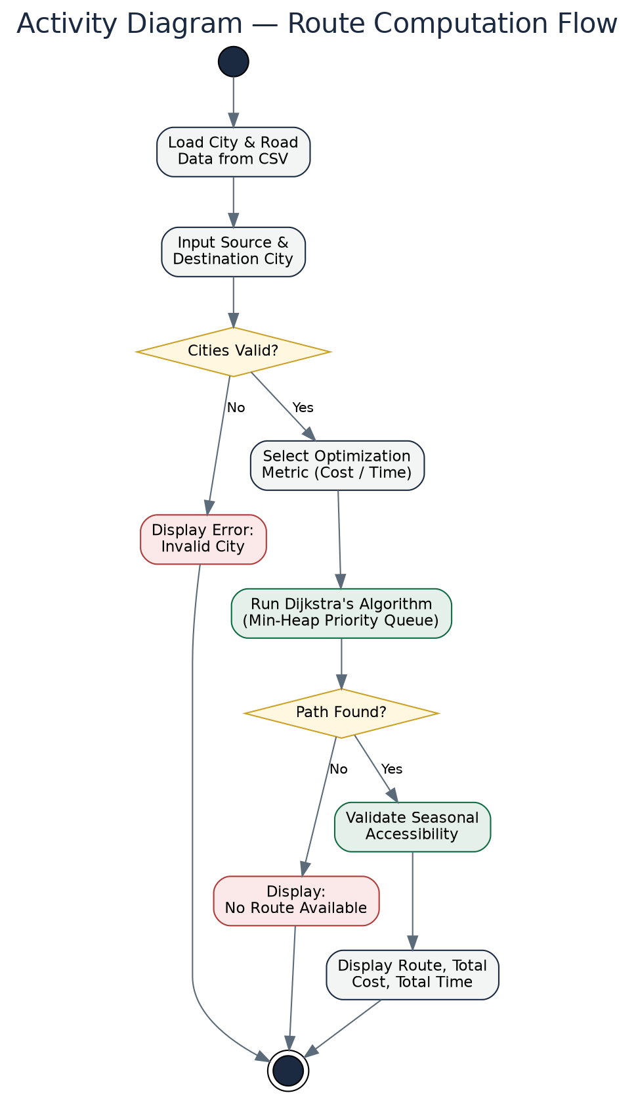
Figure 5: Activity diagram of the end-to-end route computation flow.

6 Requirements Traceability Matrix (RTM)
# | Requirement ID | Stakeholder | Priority | Validation Method
1 | FR-101 | Maintainers | High | Data Loading Integration Test
2 | FR-102 | Tourists | High | Google Test Suite (Path Accuracy)
3 | FR-103 | Tourists | High | Google Test Suite (Cost Calculation)
4 | FR-104 | Tourists | High | Functional Pruning Verification
5 | NFR-201 | Tourists | High | Performance Benchmarking / Valgrind Profiling
6 | NFR-202 | Maintainers | High | Valgrind Memory Leak & Heap Analysis
7 | NFR-203 | All | High | Edge-Case Testing (Disconnected Graph Components)
8 | NFR-204 | Maintainers | Medium | Multi-Compiler Build Verification (GCC/MSVC)
Table 4: Requirements Traceability Matrix (RTM) linking IDs to stakeholders and specific validation protocols.

7 Basic Risk Analysis
Risk ID | Description | Impact | Mitigation Strategy
R-01 | Inaccurate Weight Data: Input files containing malformed or incorrect weight values. | High | Implement a robust data validation layer during file parsing to flag anomalies.
R-02 | Algorithmic Stagnation: Potential for infinite loops if negative weights are introduced. | Medium | Implement sanity checks during graph construction to enforce non-negative weight constraints.
R-03 | Memory Overflow: Large datasets exceeding available RAM. | Medium | Utilize efficient STL containers and smart pointers; enforce adjacency list storage to maintain O(V+E).
R-04 | Disconnected Graphs: Unreachable destinations due to seasonal closures or road network gaps. | High | Implement a “No Path Found” exception handler to prevent crashes and notify the user.

8 Conclusion

8.1 Summary
The PakTour Planner provides a rigorous, DSA-driven solution for navigating the Pakistani tourism landscape. By leveraging C++17's performance capabilities and the efficiency of Dijkstra's algorithm with a binary min-heap, the system delivers a scalable and reliable planning engine. Adhering to the architectural standards defined in this SRS ensures the engine is capable of handling complex dual-metric optimizations and seasonal constraints with professional-grade stability.

